Web design assignment

Module( CSS and CSS 3)-2

**(1) What are the benefits of using CSS?**

* **Ans.:-** CSS handles the look and feel part of a web page. Using CSS, you can control the color of the text, the style of fonts, the spacing between paragraphs, how colomns are sized and laid out, etc. CSS saves time – you can write CSS once and then reuse the same sheet in multiple HTML pages.

**(2)what are the disadvantage of CSS?**

* **Ans.:-**
* **Browser Issue:** After design a web page it is not sure that the page is going to work similarly in every browser thus it can show different results in different browser.
* **Security:** There will be always security concerns while working in CSS because it is an open program that can easily effect the display by anyone if they try to disturb it.

**(3) What is the difference between CSS2 and CSS3?**

* **Ans. :-**

|  |  |
| --- | --- |
| * CSS2 | * CSS3 |
| * CSS2 is capable of positioning text and objects. | * CSS3 is capable of making the web page more attractive and takes less time to create. |
| * In contrast to CSS2, which consisted of a single document. | * CSS3 gas us uniqueness spits into many individual module, making CSS3 much easier to handle. |
| * CSS2 still has browser extension issues. | * CSS2 has complete support for aimost all browser. |

**(4) Name a few CSS style components?**

* Ans.:-
* **Selector:** HTML element name, ID name , class name
* **Property:** works like attribute like font-size, background-color, text-align, color, position, border etc.
* **Values:** which defines property or values allocate for properties.

**(5) what do you understand by CSS opacity?**

* **Ans.:-** The opacity in CSS is the property of an element that describes the transparency of the element. The content will be hidden behing an element. We can apply the opacity with different styling properties to the elements. In simple word, you can say that it specifies the clarity of the image.
* **Example:**

<!DOCTYPE html>

<html lang="en">

<head>

<meta charset="UTF-8">

<meta http-equiv="X-UA-Compatible" content="IE=edge">

<meta name="viewport" content="width=device-width, initial-scale=1.0">

<title>Document</title>

<style>

/* opacity CSS start */

h1{

background-color: green;

opacity: 0.4;

}

h2{

background-color: green;

opacity: 0.6;

}

h3{

background-color: green;

opacity: 0.8;

}

h4{

background-color: green;

opacity: 1;

}

/* opacity CSS End */

</style>

</head>

<body>

<!-- opacity in heading tag -->

<h1>background color opacity in CSS</h1>

<h2>welcome to my webpage</h2>

<h3>hello world</h3>

<h4>how are you</h4>

</body>

</html>

* **Output:**

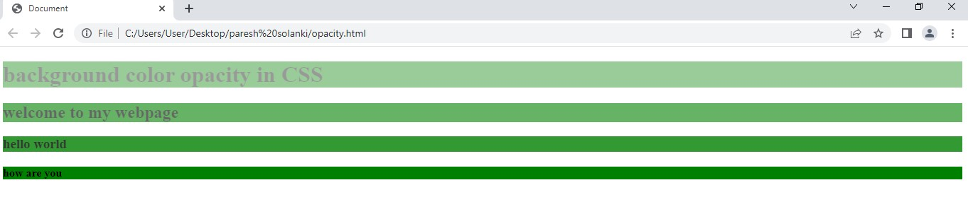

**(6)How can the background color of an element be changed?**

* Ans.:- To add background color in HTML, use the CSS background-color property. Set it to the color name or code you want and place it inside a style attribute. Then add this style attribute to an HTML element, like a table, heading, div, or span tag.
* **EXAMPLE**
* **Input:**

<!DOCTYPE html>

<html lang="en">

<!- -head start- ->

<head>

<meta charset="UTF-8">

<meta http-equiv="X-UA-Compatible" content="IE=edge">

<meta name="viewport" content="width=device-width, initial-scale=1.0">

<title>Document</title>

</head>

<!- -head end- ->

<!- -body start- ->

<body>

<!- -table start- ->

<table border="1" style="background-color: red;">

<tr style="background-color: blue;">

<td>1</td>

<td>2</td>

<td>3</td>

</tr>

<tr style="background-color: yellow;">

<td>4</td>

<td>5</td>

<td>6</td>

</tr>

</table>

<!- -table end- ->

</body>

<!- -body end- ->

</html>

* **Output:**

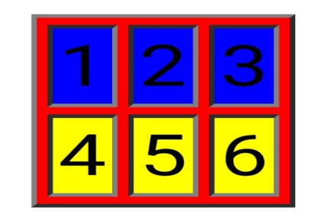

**(7)How can image repetition of the backup be controlled?**

* **Ans.:-** To control the repetition of an image in the background, use the background-repeat property. You can use no-repeat value for the background-repeat property if you do not want to repeat an image, in this case, the image will display only once.
* **EXAMPLE**

<html>

<!- -head start- ->

<head>

<style>

Body{

Background-image:url(photo.png);

Background-repeat: no-repeat;

}

</style>

</head>

<!- -head end- ->

<!- -body start- ->

<body>

</body>

<!- -body end- ->

</html>

**(8)What is the use of the background-position property?**

* **Ans.:-** The background-position property in CSS is mainly used to sets the initial position for the background image ie., it is used to set an image at a certain position. The position that is relative to the positioning layer, can be se by using the background-origin property.
* **EXAMPLE**

<html>

<!- -head start- ->

<head>

<title> background-position property </title>

<style>

Body{

Background-image:url(photo.png);

Background-position: top, left;

</style>

</head>

<!- -head end- ->

<!- -body start- ->

<body>

</body>

<!- -body end- ->

</html>

**(9)Which property controls the image scroll in the background?**

* **Ans.:-** To set the scrolling of an image in the background, use the background-attachment property.
* **EXAMPLE**

<html>

<!- -head start- ->

<head>

<style>

Body{

Background-image:url(photo.png);

Background-repeat: no-repeat;

Background-attachment:fixed;

Background-attachment:scroll;

}

</style>

</head>

<!- -head end- ->

<!- -body start- ->

<body>

</body>

<!- -body end- ->

</html>

**(10)Why should background and color be used as separate properties?**

* **Ans.:-** there are two reasons behind this:
* It enhances the legibility of style sheets. The background property in CSS, and if it is combined with color, the complexity will further increase.
* Color is an inherited property while the background is not. So this can make confusion further.

**(11)How to center block elements using CSS1?**

* **Ans.:-** The properties margin-left and margin-right can be set to auto and width to some specified value:

BODY{width:30em, background:red;}

P{width:22em; margin-left:auto; margin-right: auto}

In this case, the left and right margins will each be four ems wide, since they equally divide the remaining eight ems from (30em-22em). Note that is not necessary to set an explicit width for the BODY element; it was done here to keep the math clean.

Another example:

Table{ margin-left : auto; margin-right: auto ; width: 400px;}

In most legacy browsers, the width of a table is determined by default by its content. In CSS compliant browsers, the full width of any element (including tables) defaults to the full width of its parent element’s content area. As browsers become more compatible, authors will need to be aware of the potential impact on their design.

**(12)How to maintain the CSS specifications?**

* **Ans.:-** The specification also include:
* The syntax and data types of the language
* Detailed explanation on CSS selectors
* How you can assign values to properties
* The cascade (the “C” in CSS)
* How inheritance works
* The box model e.t.c

**(13)what are the ways to integrate CSS as a web page?**

* **Ans.:-** CSS can be added to HTML documents in 3 ways:
* Inline- by using the style attribute inside HTML elements
* Internal- by using a <style> element in the <head> section
* External- by using a <link> element to link to an external CSS file
* The most common way to add CSS, is to keep the style in external CSS files.
* **Inline CSS:-**
* An inline CSS is used to apply a unique style to a single HTML element.
* An inline CSS uses the style attribute of an HTML element.
* Inline CSS example:-

<html>

<head>

</head>

<body>

<h1 style= “color:blue;”>A blue heading</h1>  
 <p style= “color: chartreuse;”> A red paragraph. </P>

</body>

</html>

* **Internal CSS**
* An internal CSS is used to define a style for a single HTML page.
* An internal CSS is defined in the <head> section of an HTML page, within a <style> element.
* Internal CSS example:-

<html>

<head>

<style>

Body{background-color: blue;}

h1 {color: red;}

p {color:chartreuse;}

</style>

</head>

<body>

<h1> this is a heading</h1>

<p>this is a paragraph.</p>

</body>

</html>

* **External CSS:-**
* An external style sheet is used to define the style for many HTML pages.
* External CSS example:-

<html>

<head>

<link rel= “stylesheet” href= “styles.css”>

</head>

<body>

<h1> this is a paragraph</h1>

<p> this is a paragraph </p>

</body>

</html>

The external style sheet can be written in any text editor. The file must not contain any HTML code, and must be saved with a.css extension.

Here is what the “styles.css” file looks like:

“styles.css”:

Body{

Background-color: blue;

}

h1{

color:red;

}

p{

color: chartreuse;

}

* **Output:**

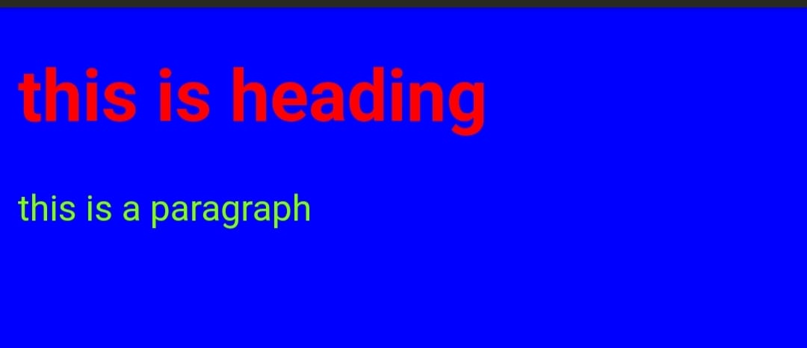

**(14)What is embedded style sheets?**

* **Ans.:-** Embedded Stylesheet: It allows you to define styles for a particular HTML document as a whole in one place. This is done by embedding the <style></style> tags containing the CSS properties in the head of your document.
* **Example:**

<!DOCTYPE html>

<html lang="en">

<head>

<meta charset="UTF-8">

<meta http-equiv="X-UA-Compatible" content="IE=edge">

<meta name="viewport" content="width=device-width, initial-scale=1.0">

<title>Document</title>

<!-- Embedded stylesheet start -->

<style>

/* heading start */

h2{

font-size: 20px;

color: red;

text-align: center;

}

/* heading end */

/* contant start */

p{

font-variant: italic;

color: cornflowerblue;

}

/* contant end */

</style>

<!-- Embedded stylesheet end -->

</head>

<body>

<!-- heading start -->

<h2>WEBCOME TO MY CLUB</h2>

<!-- heading end -->

<!-- contant start -->

<p>this document is using an embedded stylesheet</p>

<p>this is a paragraph</p>

<p>this is another paragraph</p>

<!-- contant end -->

</body>

</html>

* **Output:** 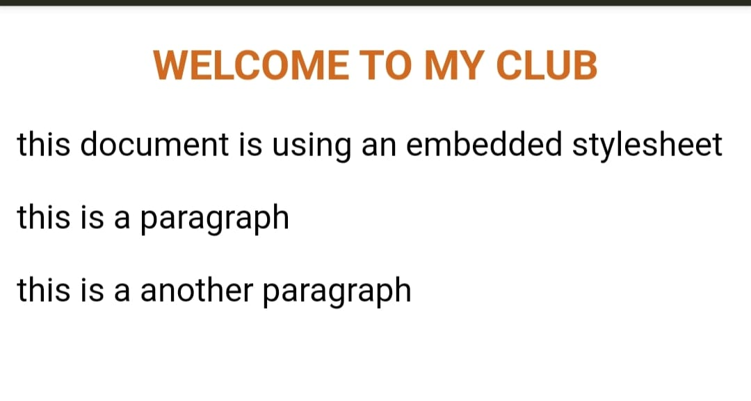

**(15)What are the external style sheets?**

* **Ans.:-** An external style sheet is a separate file linked to an HTML web page. It comes with a .css filename extension. All the styles that need to be used on a website can be declared in the external style sheet. External style sheets are an important tool from the webmaster’s perspective.
* **Example:**

<head>

<link rel= “stylesheet” type= “text/css” href= “mystyle.css”>

</head>

**(16)What are the advantages and disadvantages of using external style sheets?**

* **Ans.:-** The advantages of external style sheets are:
* Using them, the styles of multiple documents can be controlled from one file.
* Classes can be created for use on multiple HTML element types in many documents.
* In complex situations, selector and grouping methods can be used to apply styles.

The disadvantages of external style sheets are:

* in order to import style information for each document, an extra download is needed.
* Until the external style sheet is loaded, it may not be possible to render the document.
* For small number of style definitions, it is not viable.

**(17)What is the meaning of the CSS selector?**

* **Ans.:-** CSS selector are used to the content you want to style. Selectors are the part of CSS rule set. CSS selectors select HTML elements according to its id, class, type, attribute etc.
* There are several different types of selectors in CSS.

1. CSS element selector
2. CSS ID selector ( to call ID selector “#” )
3. CSS class selector ( to call class selector “.” )
4. CSS universal selector ( to call universal selector “*” )
5. CSS group selector ( to call group selector “ h1, h2” )

**(18)what are the media types allowed by CSS?**

* **Ans.:-** CSS – Media types. One of the most important feature of style sheets is that they specify how a document is to be presented on different media: on the screen, on paper, with a speech synthesizer, with a Braille device.
* The media types are:
* For mobile: 320px to 480px
* For tablets, i-pad: 481px to 768px
* For small screen, laptops: 769px to 1024px
* For desktop, large screen: 1025px to 1200px
* For extra large screen, TV: 1201px to more
* **Example:**

@media (min-width:320px) and (max-width:480px) { }

**(19)What is the rule set?**

* **Ans.:-** To create a rules set definition, select two or more data rule definitions or data rules and add them to the rule set. When a rule set is executed, the data will be evaluated based on the conditions of all rule definitions and data rules included in the rule set.

**(20)create layout**

* **Ans.:-**
* **Input:-**

**<!DOCTYPE html>**

**<html lang="en">**

**<head>**

**<meta charset="UTF-8">**

**<meta http-equiv="X-UA-Compatible" content="IE=edge">**

**<meta name="viewport" content="width=device-width, initial-scale=1.0">**

**<title>Document</title>**

**<style>**

**\* {**

**padding: 0;**

**margin: 0;**

**box-sizing: border-box;**

**}**

**/* main container CSS start */**

**.container {**

**box-sizing: border-box;**

**height: 500px;**

**width: 100%;**

**background-color: rgb(216, 213, 213);**

**padding: 20px;**

**}**

**/* main container CSS end */**

**/* box1 start */**

**.box1 {**

**box-sizing: border-box;**

**height: 200px;**

**width: 100%;**

**display: flex;**

**justify-content: space-between;**

**}**

**.one {**

**box-sizing: border-box;**

**height: inherit;**

**width: 32%;**

**background-color: black;**

**}**

**/* box1 end */**

**/* box2 start */**

**.box2 {**

**box-sizing: border-box;**

**height: 200px;**

**width: 100%;**

**margin-top: 25px;**

**display: flex;**

**justify-content: space-between;**

**}**

**.two {**

**box-sizing: border-box;**

**height: inherit;**

**width: 32%;**

**background-color: black;**

**}**

**/* box2 end */**

**/* upperbox start */**

**.upperbox {**

**box-sizing: border-box;**

**height: 50%;**

**width: 100%;**

**background-color: rgb(100, 98, 102);**

**color: white;**

**font-weight: bolder;**

**font-size: large;**

**padding-top: 40px;**

**text-align: center;**

**}**

**/* upperbox end */**

**/* belowbox start */**

**.belowbox {**

**box-sizing: border-box;**

**height: 50%;**

**width: 100%;**

**background-color: white;**

**font-size: 15px;**

**word-spacing: 5px;**

**letter-spacing: 1px;**

**text-align: center;**

**}**

**/* belowbox end */**

**/* buttto start */**

**p{**

**padding-top: 10px;**

**padding-right: 180px;**

**}**

**button{**

**font-size: 16px;**

**padding: 2px 10px;**

**}**

**/* button end */**

**</style>**

**</head>**

**<body>**

**<!-- box start -->**

**<div class="container">**

**<!-- box1 start -->**

**<div class="box1">**

**<div class="one">**

**<div class="upperbox">Thumbnail</div>**

**<div class="belowbox">this is wider card with supporting text <br>below as a natural lead in to**

**additional <br>content. this content is a little bit longer <br>**

**<p><button>View</button> <button>Edit</button></p>**

**</div>**

**</div>**

**<div class="one">**

**<div class="upperbox">Thumbnail</div>**

**<div class="belowbox">this is wider card with supporting text <br>below as a natural lead in to**

**additional <br>content. this content is a little bit longer**

**<p><button>View</button> <button>Edit</button></p></div>**

**</div>**

**<div class="one">**

**<div class="upperbox">Thumbnail</div>**

**<div class="belowbox">this is wider card with supporting text <br>below as a natural lead in to**

**additional <br>content. this content is a little bit longer**

**<p><button>View</button> <button>Edit</button></p></div>**

**</div>**

**</div>**

**<!-- box1 end -->**

**<!-- box2 start -->**

**<div class="box2">**

**<div class="two">**

**<div class="upperbox">Thumbnail</div>**

**<div class="belowbox">this is wider card with supporting text <br>below as a natural lead in to**

**additional <br>content. this content is a little bit longer**

**<p><button>View</button> <button>Edit</button></p></div>**

**</div>**

**<div class="two">**

**<div class="upperbox">Thumbnail</div>**

**<div class="belowbox">this is wider card with supporting text <br>below as a natural lead in to**

**additional <br>content. this content is a little bit longer**

**<p><button>View</button> <button>Edit</button></p></div>**

**</div>**

**<div class="two">**

**<div class="upperbox">Thumbnail</div>**

**<div class="belowbox">this is wider card with supporting text <br>below as a natural lead in to**

**additional <br>content. this content is a little bit longer**

**<p><button>View</button> <button>Edit</button></p></div>**

**</div>**

**</div>**

**<!-- box2 end -->**

**</div>**

**<!-- box end -->**

**</body>**

**</html>**

* **Output:-** 